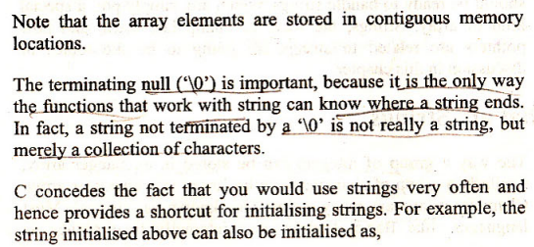

**What is the output of the above program 33?**



**Please read below once you got the output of Program 34:**

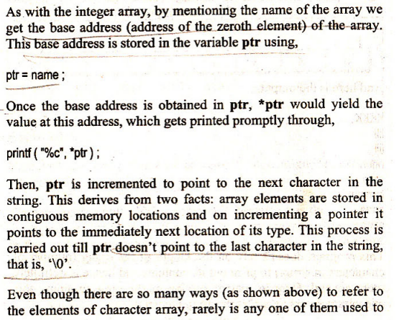

**Program 36:**

**WAP to accept a string from the user and print it.**

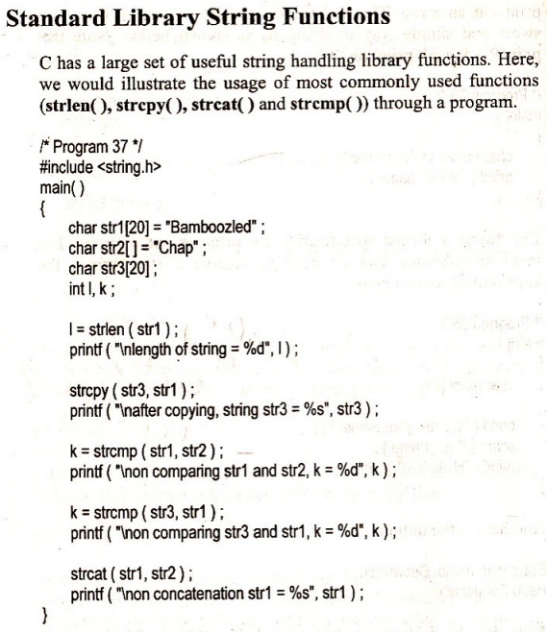

**What is the output of the Program 37?**

**Read below after you got the right output  
**

**What is the output of Program 38?**

**Read Program 39 below and try it out. Show it to Mom.  
**

**Read and try Program 40 below and show it to Mom:  
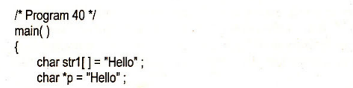**

**Try Program 41 below and show it to Mom:**

**Try the program, and show it to Mom.  
**

**WAP to return a pointer to a constant string.**